1
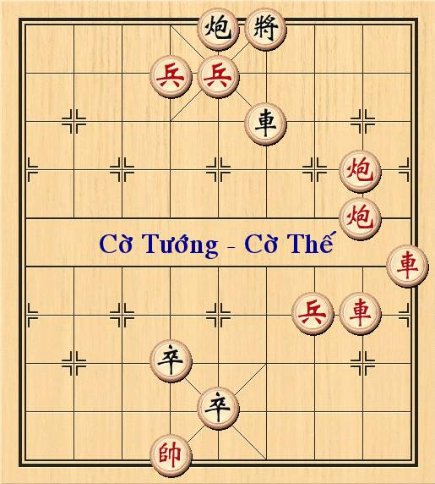 | - B5.1 (chieu); Tg6-5  - X1-5 (chieu); Tg5-6  - P2t-4; X6.1  - P2s-4; X6-5  - X2.6; Tg6.1  - B6-5 (chieu); X5/2  - X5/3; X5.7  - X2-6; B4-3  - X6/8 (thi xe de cau hue co); X5/4  - P4/4; X5.3  - X6-9; Tg6.5  - P4-5 (chieu); X5-7  - P5/1; X7/1  - X9-5 (chieu); Tg5-6  - P5-4; X7.3Tg6-5  * Biến 1:  - X4.1; B2-3  - X4- 6; X7-6  Toi day moi ben con 1 xe = => Hue co  * Biến 2:  16. X4.1; B2.1  17. X4/1; X7/3  - X4/5 (chieu) ; Tg5-6  - Tg6.1; X7/3  - X5-7 (an chot)  Toi day do con xe phao, xanh con moi xe = => do win

2
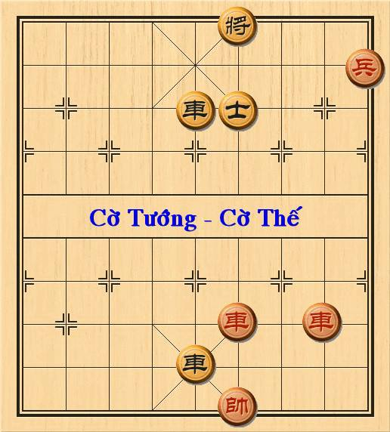 | - X2.7; Tg6.1  - X2/1; Tg6/1  - X2-5; X5s/1  - X4.5; X5-6  - X4.1; Tg6-5  Toi day do con Xe + Chot, den con 1 Xe ➔ Do win?

3
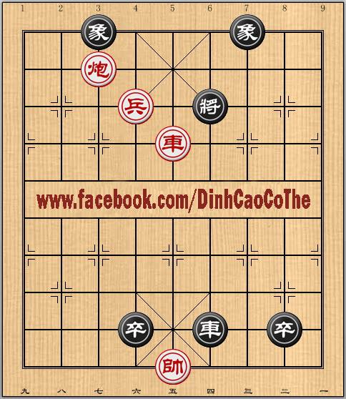 | 1; P7/1 TG6/1 (nếu v3.5 thì c6-5 rồi đánh tương tự)  2; P7/7 C8.1  3; X5.2 TG6/1 ( TG6.1 P7.7 ĐỎ WIN)  4; X5.1 TG6.1  5: C6.1 X6-5  6; X5/8 C4-5  7; TG5.1 ➔ hòa cờ

BÁ LỘNG TẠO HÓA
(3a1kbn1/4P4/1c2n1r2/4p4/9/CC5pp/9/9/r1p1p4/3K3RR w - - 0 1)
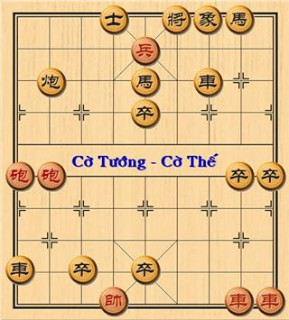 | (http://cotuongvietnam.vn/showthread.php?923-Nhung-van-co-the-tren-Ky-Dai-Newlink.html/page2)

TAM TINH TỤ HỘI
(5k3/3PP4/9/4Nr3/9/9/7C1/4p2C1/3p1p3/4K2R1 w - - 0 1)
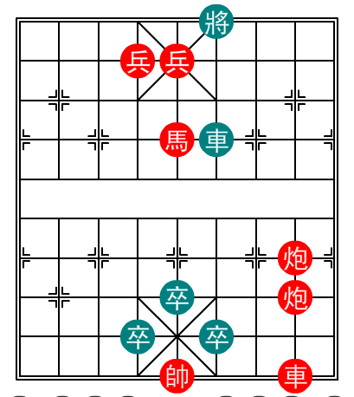 | (http://www.thegioicotuong.com/posts/list/5062.htm)

Tam quân bảo giá
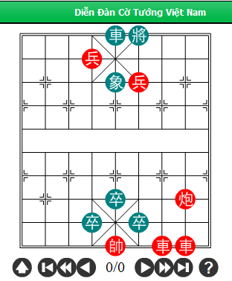 | (http://cotuongvietnam.vn/showthread.php?923-Nhung-van-co-the-tren-Ky-Dai-Newlink.html/page2)  - P2-4 (chieu); B5-6  - B4.1 (chieu); Tg6.1  - X3.8 (chieu); Tg6/1  - X2.1;  - …

TỨ LINH
